Experiment 12
Calculate Area and Perimeter Using
Problem Statement
Write a Java Program to create an interface having prototypes of functions ‘area()‘ and
‘perimeter()‘. Create two classes ‘Circle‘ and ‘Rectangle‘ which implement the above
interface. Develop a menu-driven program to find the area and perimeter of these shapes.

Source Code :
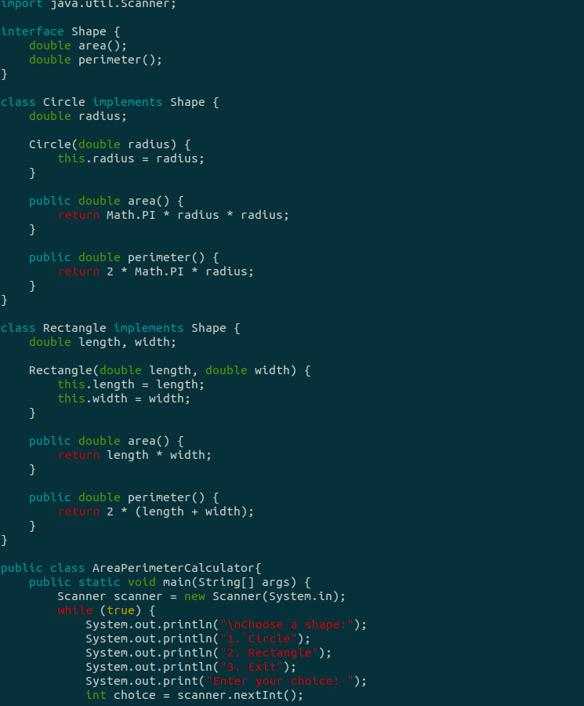

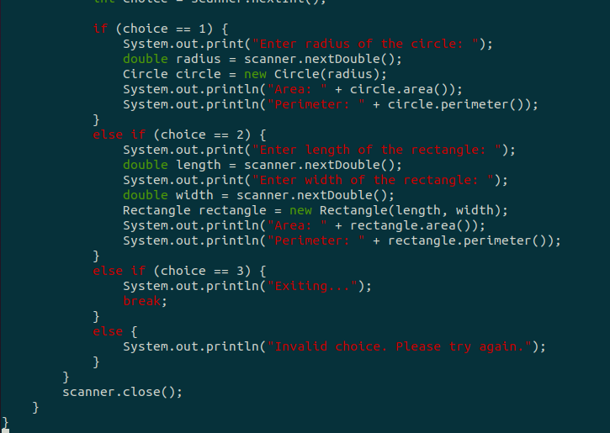

Output :

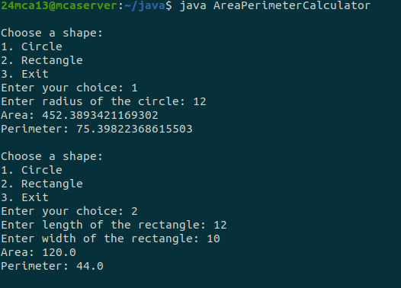

Experiment 13
Program to Manage Employee
Collection
Problem Statement
Create a Java program to manage a collection of employees in a company. Implement an
abstract class Employee with fields name (String) and salary (double), and an abstract
method calculateSalary(). Create two subclasses: Manager (with a bonus field) and
Developer (with an experience field), both overriding calculateSalary() to calculate
the total salary. Implement an interface Benefits with a method calculateBenefits(),
where Manager provides a fixed insurance benefit and Developer provides an allowance
based on experience. Use polymorphism to store Employee objects in a list and display
employee details and salary. Add method overloading in Manager for project assignment,
where one method takes just a project name and the other takes both the project name
and the number of team members.

Source Code :

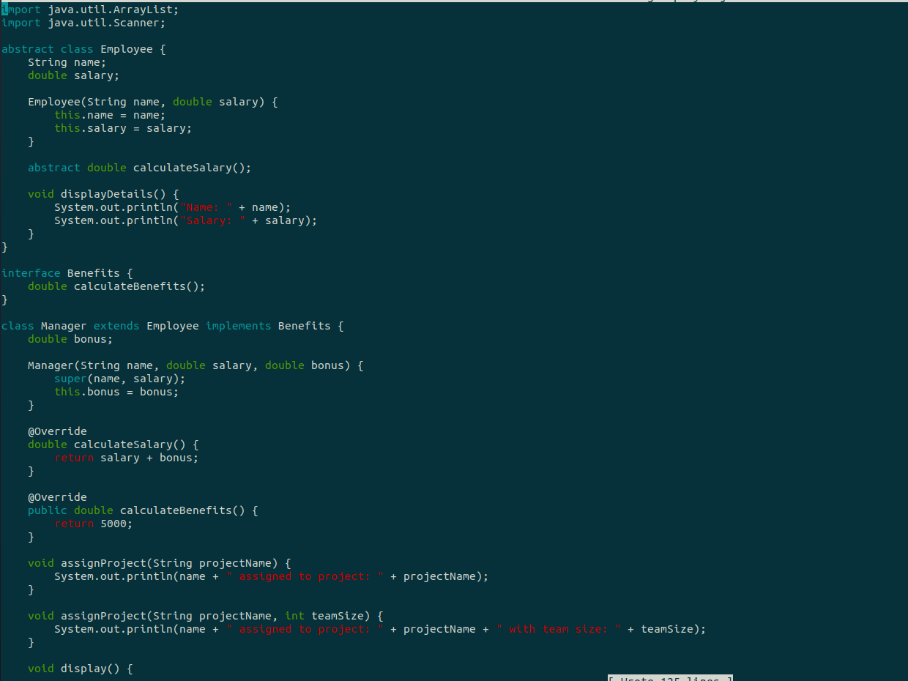
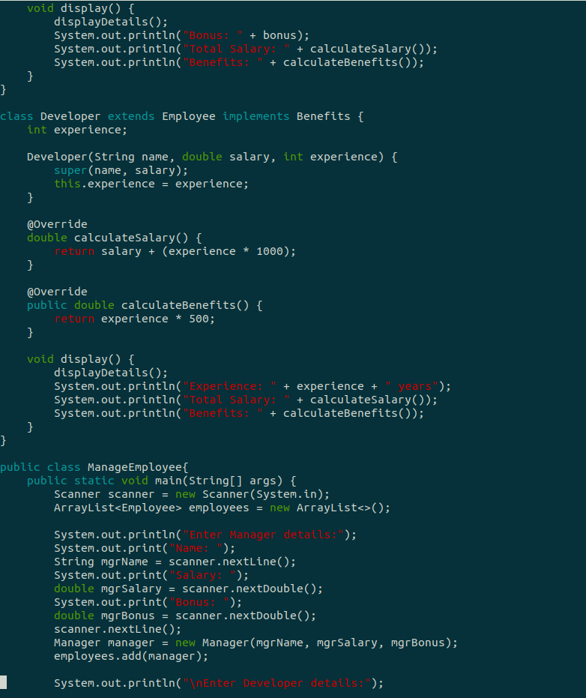
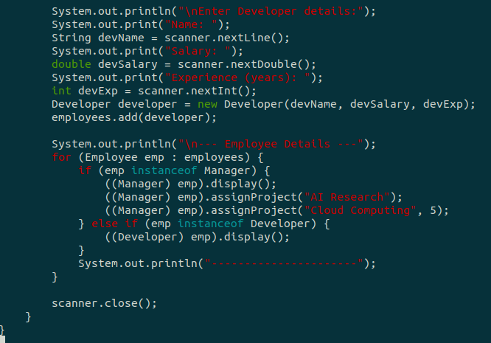

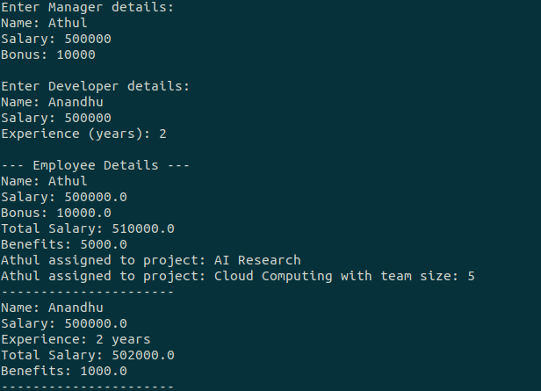
Output :Shape

Experiment 14
Graphics Package for Geometric
Figures
Problem Statement

Create a Graphics package that contains classes and interfaces for geometric figures such
as ‘Rectangle‘, ‘Triangle‘, ‘Square‘, and ‘Circle‘. Test the package by finding the area of
these figures.

Source Code :

src/Main.java
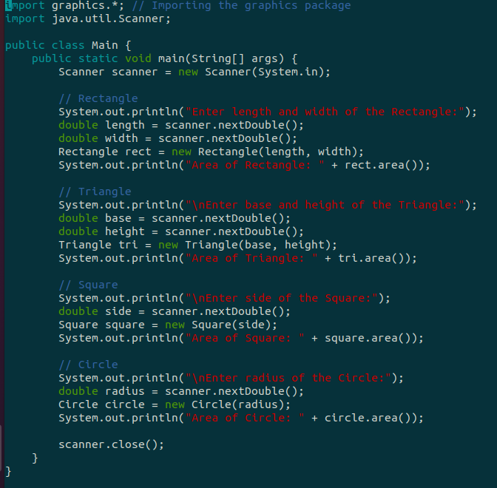
graphics/Circle.java

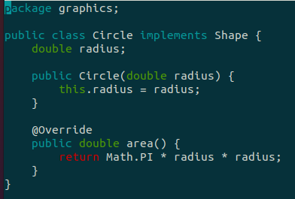

graphics/Rectangle.java

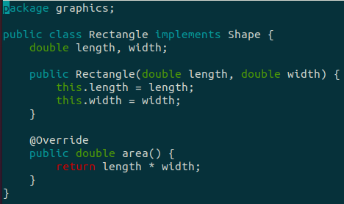

graphics/Shape.java

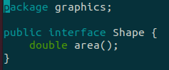
graphics/Square.java
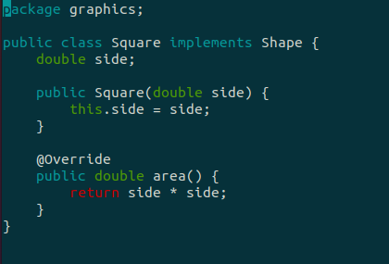

graphics/Triangle.java

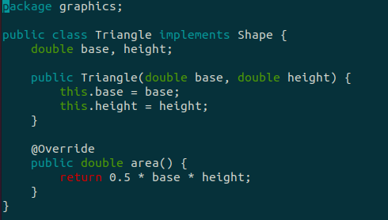

Output :
